Chemistry 115 Name
Dr. Cary Willard
Quiz 2A (20 points) February 12, 2009

All work must be shown to receive credit.

- (5 points) Use dimensional analysis to determine the number of dimes that are equal to 327 quarters.

$$?dimes=327 quarters×\frac{5 nickels}{1 quarter}×\frac{1 dime}{2 nickels}=818 dimes$$

- (5 points) A horse has a mass of 487 kg. What is the mass of the horse in ounces? (1 lb = 16 ounces)

$$?ounces=487 kg×\frac{2.20 lb}{1 kg}×\frac{16 oz}{1 lb}=1.71×{10}^{4}ounces$$

- (5 points) A bottle of soda holds 345 mL of soda. How many μL (microliters) of soda does the bottle hold?

$$? μL=345 mL×\frac{1 L}{1000 mL}×\frac{1000000 μL }{1 L}=3.45×{10}^{3} μL$$

- (5 points) The ruler below is calibrated to measure centimeters. How long is the line in cm? 5.75 cm

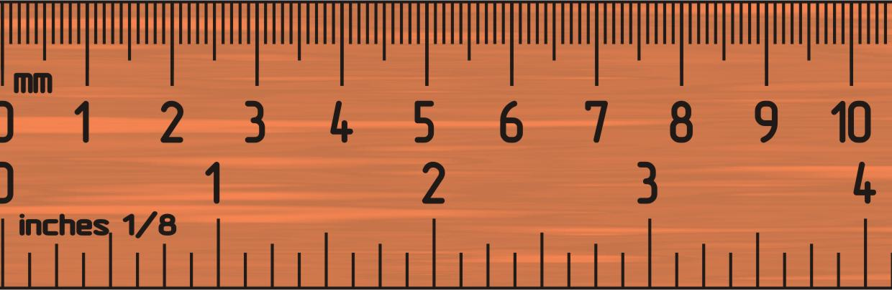
Chemistry 115 Name
Dr. Cary Willard
Quiz 2B (20 points) February 12, 2009

All work must be shown to receive credit.

- (5 points) Use dimensional analysis to determine the number of dimes that are equal to 255 quarters.

$$?dimes=255 quarters×\frac{5 nickels}{1 quarter}×\frac{1 dime}{2 nickels}=638 dimes$$

- (5 points) A horse has a mass of 571 kg. What is the mass of the horse in ounces? (1 lb = 16 ounces)

$$?ounces=571 kg×\frac{2.20 lb}{1 kg}×\frac{16 oz}{1 lb}=2.01×{10}^{4}ounces$$

- (5 points) A bottle of soda holds 255 mL of soda. How many μL (microliters) of soda does the bottle hold?

$$? μL=225 mL×\frac{1 L}{1000 mL}×\frac{1000000 μL }{1 L}=2.25×{10}^{3} μL$$

- (5 points) The ruler below is calibrated to measure centimeters. How long is the line in cm? 7.25 cm

